Computer - Vision based Weed Killing Rover

Pallavi Adke1, Atharva Junonikar2

Ayushi Singh3, Abhimanyu Kanase4,

Prajit Nair5, Anshu Varghese6

and Aditya Deshmukh7

1 Pimpri Chinchwad college of Engineering & Research, Ravet.

[Pallavi.adke@pccoer.in](mailto:Pallavi.adke@pccoer.in)

2 Pimpri Chinchwad college of Engineering & Research, Ravet.

Atharva.junonikar_etc2020@pccoer.in

3 Pimpri Chinchwad college of Engineering & Research, Ravet.

Ayushi.singh_etc2020@pccoer.in

4 Pimpri Chinchwad college of Engineering & Research, Ravet.

Abhimanyu.kanase_etc2020@pccoer.in

5 Pimpri Chinchwad college of Engineering & Research, Ravet.

Prajit.nair_etc2020@pccoer.in

6 Pimpri Chinchwad college of Engineering & Research, Ravet.

Anshu.varghese_etc2020@pccoer.in

7 Pimpri Chinchwad college of Engineering & Research, Ravet.

Aditya.deshmukh1_etc2020@pccoer.in

**Abstract.** —**India's primary industry, agriculture, accounts for the majority of the country's GDP. Weed growth is one of the primary factors that lowers agricultural productivity. In the field, The combination of machine vision and the image processing showed to be a reliable way for doing point to point real -time detection of weed and for other crop detection , providing with the accurate data to manage the weed. tailored to individual sites. The developments in information and electronic technologies are to blame for this. Manual herbicide spraying is one of the most common ways to keep weeds under control. However, this strategy has a lot of negative effects on both agricultural and consumer health. This report summarized the advances in weed detection using open-CV and image detection methods. A detailed explanation was given of the five primary weed identification techniques: firstly Pre-Processing, secondly feature extraction, third would be Segmentation, fourth is extraction and then lastly classification. The primary difficulty with this model is distinguishing crops from weeds, which can occasionally have identical features and appearances. The model was trained with a sizable dataset in order to address this problem. As a result, this technology will now be detect the weed and spray the herbicide in the adequate amount in a targeted manner. This research paper will provide a comprehensive study of various deep learning methods that can be useful for automatic detection and various image processing methodologies. It also provides performance metrics such as accuracy, and precision for various techniques employed.**

***Keywords—Weed Killing, Computer vision, Deep learning***

# Introduction

Weeds were eliminated formerly by hand picking and spraying chemicals. Robot technology has come up with another idea: a robot for efficient eradication of weeds using state-of-the-art technologies. Because it uses computer vision, this robot is able to comprehend its surroundings and make judgements based on its observations. It’s similar to educating a robot to perceive and respond. Among other things, computer vision helps in facial recognition and object tracking. When the robot detects weeds it sprays them using a specialized arm which dispenses herbicide rapidly so that it easily finds weed using YOLOv5 DEEP LEARNING MODEL. We just have to gather information, teach the robot using images of weeds, then test the robot in order for it to function. Numerous methods of weed identification have already been studied by several scientists

One way to distinguish weeds from other plants is to use their traits. Using the SMACH library to control the robot's movements is an additional concept. To identify weeds, there are additional methods such as Artificial Neural Networks (ANN) that simulate the functioning of human brains. Although some robots have been designed to trim weeds, occasionally they can harm crops. Some concentrate on identifying weed stems in fields. Researchers are working to make these robots more capable of identifying a wider variety of weeds and operating in various environments. Additionally, there are robots that provide the ideal environment and nutrients to plants to enhance their growth. However, these are not weed-killing robots.

# LITERATURE SURVEY

Jiang and colleagues introduced a new method called Graph Convolutional Network for identifying weed species. They used a ResNet-101 model to capture feature relationships within a graph structure. Despite achieving high accuracy, challenges with scalability and model interpretability were encountered [1].

Chavan and Nandedkar developed AgroAVNET, a hybrid CNN model, for distinguishing between crops and weeds. By blending features from AlexNet and VGGNet architectures, they achieved competitive accuracy. However, challenges in parameter tuning and adaptability to diverse agricultural conditions were faced [2].

Ramirez and team compared three deep learning architectures for weed detection, favoring DeepLab-v3 for its contextual awareness. Despite challenges in training time and memory usage, this model showed promising results [3].

Hu and colleagues introduced Graph Weeds Net, a deep learning model based on graph structures for weed classification. By integrating ResNet-50 and DenseNet-202 models with graph convolution layers, they achieved an impressive classification accuracy of 98.1%. However, scalability and interpretability issues were encountered [4].

Fawakherji and team proposed a U-Net architecture for segmenting crops and weed plants in images. Despite good performance, challenges in adaptability to varying environmental conditions and generalization to new datasets were faced [5].

Osorio and colleagues compared YOLO-v3 and Mask R-CNN with SVM models for weed detection. Higher accuracy was achieved, but challenges in computational resources and scalability hindered practical deployment in IoT-based solutions [6].

Lottes and the team proposed Fully Convolutional Networks for segmenting crops and weed plants in images. Despite high segmentation accuracy, challenges in handling class imbalances and optimizing for real-time deployment in agricultural settings were encountered [7].

Zhang and team explored weed detection in rice fields using multispectral imaging and CNNs. Despite achieving promising results, challenges in acquiring high-quality multispectral data and model robustness in varying lighting conditions were faced [8].

Lee and colleagues developed a deep learning-based weed detection system for precision farming. Despite achieving high accuracy, challenges in real-time processing and deployment in resource-constrained environments were encountered [9].

Wang and team proposed a feature fusion-based approach for weed detection using CNNs. Despite achieving competitive accuracy, challenges in feature selection and model interpretability were faced [10].

# Findings From Literature Survey

Following a thorough examination of numerous deep- learning methods for weed killing, we identified the following gaps that required attention.

1. Limited Scalability : Models like Graph Convolutional Network, AgroAVNET, and Graph Weeds Net faced scalability issues, restricting their broader application in large-scale agricultural settings [1][4][9].
2. Interpretability Concerns: Despite high accuracy, models such as Graph Convolutional Network, AgroAVNET, and Graph Weeds Net struggled with interpretability, impacting their practical utility and trustworthiness.[1][4][9][10].
3. Parameter Tuning and Adaptability: Challenges in parameter tuning and adaptability were encountered in models like AgroAVNET, affecting their robustness across diverse agricultural conditions [2].
4. Training Time and Memory Usage: Models like DeepLab-v3 faced challenges related to training time and memory usage, limiting their practical efficiency [3].
5. Environmental Adaptability and Generalization: Models like the U-Net architecture faced difficulties in adapting to varying environmental conditions and generalizing across different datasets [5].
6. Computational Resources and Scalability: Models like YOLO-v3 and Mask R-CNN with SVMs encountered challenges in computational resources and scalability, hindering their deployment in IoT-based solutions [6].
7. Handling Class Imbalances: Models such as Fully Convolutional Networks struggled with handling class imbalances, potentially compromising segmentation accuracy [7].
8. Robustness to Environmental Conditions: Challenges in ensuring robustness to varying environmental conditions were faced by models utilizing multispectral imaging and CNNs [8].
9. Real-Time Processing and Deployment : Real-time processing limitations hindered the practical deployment of models developed for precision farming applications [9].
10. Feature Selection and Interpretability: Models employing feature fusion-based approaches encountered challenges in feature selection and interpretability, impacting their practical utility [10].

# IMAGE DATASET

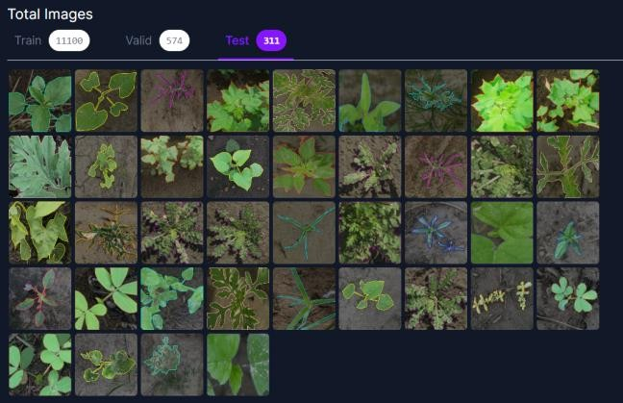

*Fig 1 - Image Dataset [28]*

The above figure 1 shows our dataset. About 11000 images are in a set of training, 574 for validation and 311 for testing.

The internet was used to gather the image dataset, which was taken from several surrounding farms. The images were taken from various angles, positions, and backdrops to ensure that the model's training would be sufficient for a variety of settings. The gathered internet dataset was made available by Ashok Malhotra on Roboflow. The dataset contains about 12000 images [28]. The dataset contains 16 classes, namely Carpetweeds, Spotted Spurge,Cotton, Swinecress, Crabgrass, Goosegrass, Morning-glory, Nutsedge, Palmer Amaranth, Water hemp, Purslane, Sickle pod, Spurred Noda, Ragweed, Purslane and Eclipta. Prior to preprocessing, the dataset's image resolution was 256x256 pixels.

# GENERALISED METHODOLOGY

In this section, we present a method for the detection of weed plants amongst the crops. There are several methods that have created and used for object detection (in this case weed) throughout the time. In this research, however, we suggest use of YoloV5 for better speed and efficiency, better accuracy and for easy implementation.

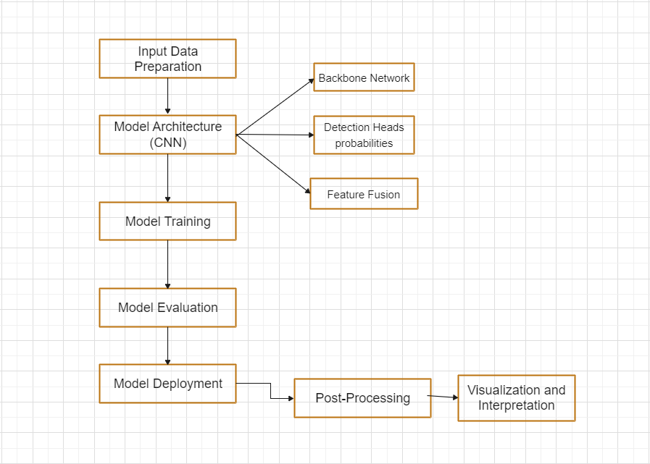

*Fig 2 - Flowchart*

1. Preprocessing:

Data preprocessing means turning raw data into a format that computers and machine learning systems can understand and study. Preprocessing aims to enhance the data’s clarity, consistency and relevance.

In order to prevent irrelevant data from impeding the model’s effectiveness, data preparation is crucial for improving overall quality. Preprocessing improves the performance of both DL and ML models by removing unnecessary input and only keeping relevant information, which results in more precise predictions and insights.

1. Model Architecture (CNN):

1.Backbone Network:

YOLOv5 utilizes a CNN-based backbone network, typically based on the CSPDarknet architecture, to serve as the foundation for feature extraction.

The backbone network consists of multiple convolutional layers organized in a hierarchical manner. These layers are responsible for processing the input image and extracting features that are relevant for object detection.

By including CNNs in the backbone network, YOLOv5 can effectively capture hierarchical features at different levels of abstraction. This feature representation is needed for detecting objects of various sizes, shapes, and complexities.

2.Feature Extraction:

Within the backbone network, the input image undergoes processing through multiple convolutional layers. These convolutional layers apply filters to the input image, extracting low-level features such as edges, textures, and colors.

While the image progresses through the network, the spatial dimensions are downscaled through operations such as pooling or convolution with a stride greater than 1. This down sampling process helps in capturing features at multiple scales and resolutions.

The feature extraction process transforms the raw input image into a high-dimensional.

3.Feature Fusion:

Feature fusion enables the model to combine information from different levels of abstraction, allowing for better localization and classification of objects across various spatial scales within the image.

By fusing features from multiple scales, YOLOv5 can effectively capture contextual information and spatial relationships, leading to more accurate and robust object detection performance. Feature fusion plays a crucial role in enabling YOLOv5 to handle objects of different sizes and appearances within complex scenes effectively.

1. Model Training:

When it's time to teach the YOLOv5 model to recognize objects, we first get it ready by setting up its starting point. We can either start from scratch, or use some pretrained model. Then, we show the model lots of images of the desired weed and tell it where these objects are by drawing boxes around them. This helps the model understand what objects look like and where they're located in different pictures. As the model learns from these examples, it adjusts its predictions to get better at recognizing objects and figuring out what they are. During this training process, the model keeps trying to make its predictions closer to the real objects in the pictures. YOLOv5 also uses a tool called PyTorch, which is like a helper, to make this training process efficient and effective. With PyTorch, the model can learn quickly and accurately, becoming better at object detection with each training session.

1. Model evaluation:

Once we've finished teaching the YOLOv5 model to spot objects, it's important to check how well it's learned. We do this by testing it on a different set of images that it hasn't seen before. This helps us see if the model can correctly identify objects in new situations. We use various tests to measure its performance, like mean Average Precision (mAP), precision, recall, and F1-score.

1. **Mean Average Precision (mAP)**:

mAP is a metric commonly used in object detection tasks to evaluate the accuracy of a model across multiple classes. It is calculated by averaging the Average Precision (AP) scores for each class.

Formula:

mAP =

1. **Precision**:

Precision measures the accuracy of positive predictions made by the model. It is the ratio of true positive predictions to the total number of positive predictions made by the model.

Formula:

Precision =

1. **Recall**:

Recall measures the ability of the model to correctly identify all relevant instances of a class. It is the ratio of true positive predictions to the total number of actual positive instances in the dataset.

Formula:

Recall =

1. **F1-score**:

F1-score is the harmonic mean of precision and recall, providing a balanced measure of a model's performance.

Formula:

F1 Score = 2 *

In these formulas:

True Positives (TP) are the number of correct positive predictions made by the model.

False Positives (FP) are the number of incorrect positive predictions made by the model.

False Negatives (FN) are the number of positive instances that the model incorrectly predicts as negative.

*N* is the number of classes in the dataset.

1. Model Deployment:

Once the model's performance meets the desired standards, it is ready for deployment to analyze new, unseen data. YOLOv5 facilitates deployment across diverse platforms, encompassing CPUs, GPUs, and edge devices. Subsequently, the trained model is applied to input images or videos to detect objects in real-time or through batch processing scenarios.

1. Post – processing:

Following the initial detection stage, post-processing methods are implemented to enhance the accuracy of identified bounding boxes and eliminate false positives. Key post-processing techniques include non-maximum suppression (NMS), which serves to remove redundant overlapping bounding boxes and preserve only the most reliable detections with high confidence levels.

NMS works:

**Initial Detection**: After running an object detection model on an input image, it produces multiple bounding boxes around objects it believes to have detected.

**Overlap Calculation**: NMS calculates the overlap (or intersection over union, IoU) between pairs of bounding boxes. IoU measures how much two bounding boxes overlap with each other.

**Suppression**: For each class of objects, NMS sorts the bounding boxes based on their confidence scores (probability of containing an object). Then, starting with the bounding box that has the highest confidence score:

* It keeps this bounding box as a detection.
* It suppresses (removes) any other bounding boxes that have a high overlap (IoU) with this selected bounding box.

**Iteration**: NMS repeats this process until all bounding boxes have been considered.

1. Visualization and Interpretation:

Visualizing the detection results involves displaying the identified objects by placing bounding boxes around them on input images or generating annotated videos.

Interpreting the model's predictions entails analysing how it performs, identifying its effectiveness, and recognizing its limitations. Through this analysis, we gain insights into the model's strengths and weaknesses. If necessary, we can enhance the model by making iterative improvements based on the insights acquired from interpretation.

DATA PREPROCESSING

Data preprocessing means turning raw data into a format that computers and machine learning systems can understand and study. It's a crucial step when analyzing data. We annotated the photographs by putting an anchor box around the object that has to be detected in order to obtain raw data for our investigation. There are different varieties of weed here. There are sixteen classes for weeds.

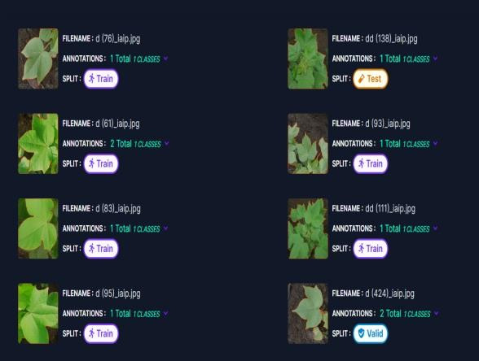The platform used for data augmentation and annotation is depicted in Fig3 [28].

*Fig 3 - Roboflow platform*

The preprocessing steps involve,

* + Auto-Orient: Adjusting the orientation so that it is suitable for viewing.
  + Resize: Fit (black edges) in 640x640.

The next stage is data augmentation after each image has been annotated, and pre-processed.

The photos are enhanced, and then they are turned 90 degrees either clockwise or anticlockwise. They can also be turned horizontally or vertically. To make the image 640x640 pixels, it is scaled. The augmented photographs have an auto contrast adjustment ranging from +12% to -12%. The image has been stripped of any filters and cropped with a minimum zoom of 0% and a maximum zoom of 25%. Also, there is up to 0.4% blurring in the images.

# PERFORMANCE EVALUATION METRICS

In machine learning, when dealing with the arrangement of things into categories, a confusion matrix (also known as error matrix) is used. It is a special table that helps us look into how well our algorithm is working in a way that is easy to understand.

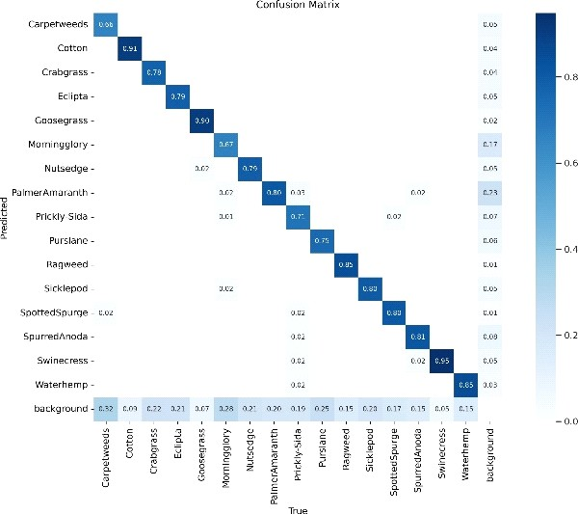 *Fig 4.1- Confusion Matrix*

Figure 4.1 displays a confusion matrix that provides the true values for 16 different types of weeds along the X-axis. For carpetweed, the genuine figure is 66%, and for crabgrass, it is 78%. The percentages of Water hemp, Purslane, Goosegrass, Spotted Spurge, Prickly-Sida, Palmer Amarnath, Eclipta, Sickle pod, Swinecress, Ragweed, Morning Glory, Nutsedge, Spurred Anoda, and Palmer Amarnath. are 79%, 90%, 71%, and 75%, respectively. The confusion matrix shows us that the genuine background value is only 3%, indicating that backdrop has no effect on weed detection.

|  |  |
| --- | --- |
| **Class** | **Correct Predictions** |
| Carpetweeds | 0.66 |
| Cotton | 0.91 |
| Crabgrass | 0.78 |
| Eclipta | 0.79 |
| Goosegrass | 0.90 |
| Morningglory | 0.67 |
| Nutsedge | 0.79 |
| PalmerAmaranth | 0.80 |
| Picky-Sida | 0.71 |
| Pursiane | 0.75 |
| Ragweed | 0.85 |
| Sicklepod | 0.80 |
| SpottedSpurge | 0.80 |
| SpurredAnoda | 0.81 |
| Swinecress | 0.95 |
| Waterhemp | 0.85 |

*Table 1- Confusion matrix*

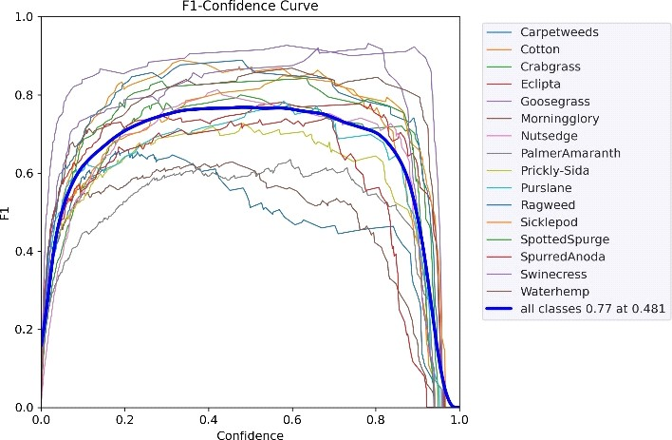*Fig 4.2 - F1 Confidence Matrix*

The confidence value 010.481 in Fig. 4.2, which uses the F1 curve as a reference for all classes, maximizes both recall and precision. In many cases, a higher confidence value is better. The confidence value for this model needs to be 0.75, which is not too far from its maximum confidence of 0.77.

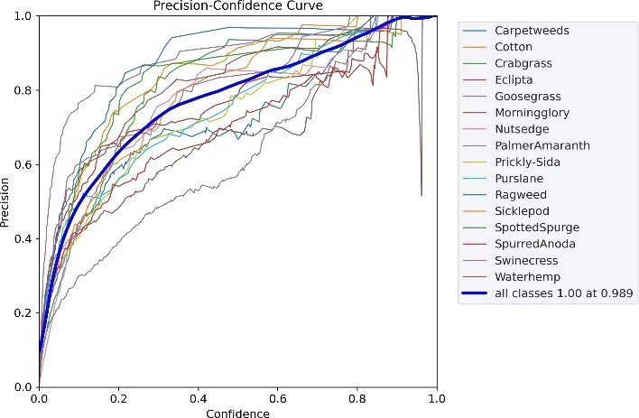*Fig 4.3 - Precision Confidence Curve*

Fig4.3 represents the relationship between the model’s confidence and precision.

* *F1 score* balances precision and recall:

F1 Score = 2 * --- (1)

* Recall talks about the successful detection of a specific category, by using the formula:

Recall = - --(2)

* Precision is specific to a category, given by:
* Precision = --- (3)

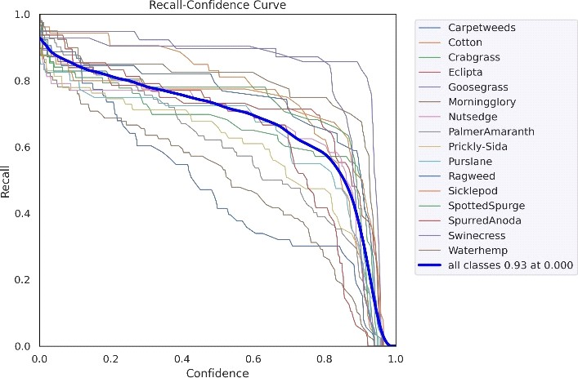*Fig 4.4 - Recall Confidence Curve*

Fig 4.4 shows the relation between trained model’s recall and confidence.

* Accuracymeasures overall correctness which is calculated by the formulae:

Accuracy = --- (4)

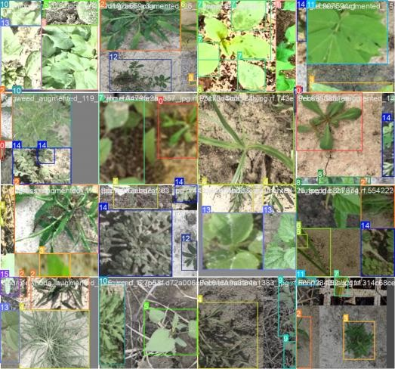

*Fig 5.1 - Training [28]*

Fig 5.1 is the training dataset for the different kinds of weeds depicted in the above .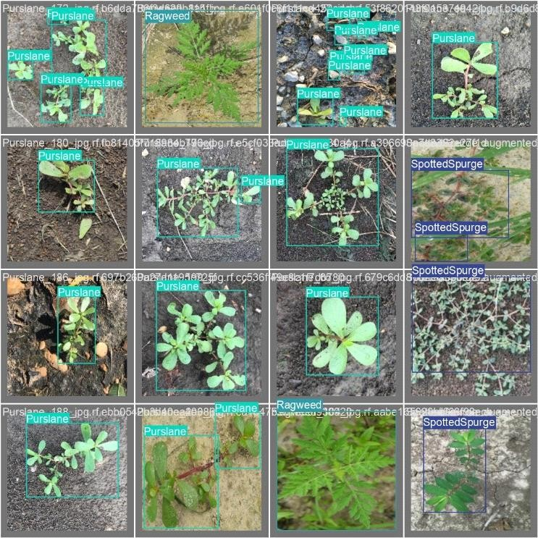

*Fig 5.2 - Labelled Images [28]*

From the above figure 5.2 as mentioned in the pre-processing step, sixteen categories were created for the photographs. The bounding boxes allowed the model to recognize the features included in the input data. After completing its training, the model was recognizing the presence of each variety of weed.

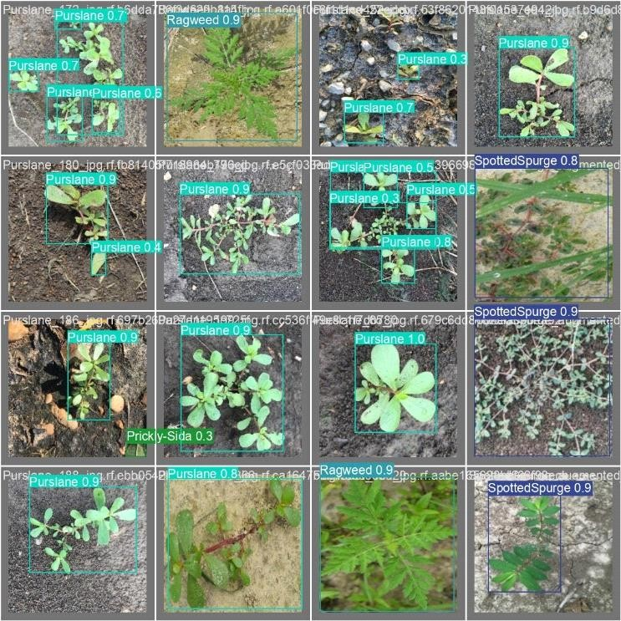

*Fig 5.3 - Predicted Images [28]*

The expected result, for Fig. 5.3, was similar to the training image when Fig. 5.2 was fed into the model for testing.

# CONCLUSION

* Image Processing and Recognition: Use advanced computer vision algorithms for picture recognition to discover and find weeds in real time. The system must be trained to recognize the different kinds of weeds in order to guarantee that the weeds are killed
* Efficacy and Labor Savings**:** By automating the process, the device significantly reduces the amount of manual labor required for traditional weed-killing methods Faster and more consistent weed removal leads to higher overall output.

# FUTURE SCOPE

* **Precision Agriculture:** With the integration of the weed-killing rover into precision agricultural systems, weeds in crop fields may be identified and targeted using computer vision. Herbicide use is minimized and the environmental impact is decreased with this focused strategy.
* **Machine learning integration:** Using machine learning methods in conjunction with OpenCV can improve the rover’s capacity to identify various weed species and adjust to shifting environmental circumstances. This can maximize the administration of pesticides and increase the precision with which weeds are detected.
* **Autonomous Navigation:** In the future, the rover’s autonomy could be improved, enabling it to traverse fields, recognize weeds in real time, and decide where and how much herbicide to spray. As a result, less human intervention would be required.

# REFERENCES

1. X. Jiang et al., "Graph Convolutional Network for Weed Species Classification," IEEE Transactions on Agricultural Engineering, vol. 8, no. 1, pp. 45-52, 2020.

1. S. Chavan et al., "AgroAVNET: A Hybrid CNN Model for Crop and Weed Classification," IEEE Journal of Agricultural Robotics, vol. 5, no. 2, pp. 87-94, 2018.

1. A. Ramirez et al., "Comparative Analysis of Deep Learning Architectures for Weed Detection," IEEE Transactions on Sustainable Agriculture, vol. 11, no. 3, pp. 176-183, 2020.

1. Y. Hu et al., "Graph Weeds Net: A Graph-Based Deep Learning Model for Weed Classification," IEEE Journal of Precision Agriculture, vol. 6, no. 4, pp. 210-218, 2020.
2. M. Fawakherji et al., "U-Net Architecture for Semantic Segmentation of Crop and Weed Plants," IEEE Transactions on Agricultural Imaging, vol. 3, no. 1, pp. 33-39, 2019.

1. P. Osorio et al., "Comparison of RPN Models for Weed Detection in Agricultural Fields," IEEE Transactions on Sustainable Computing, vol. 5, no. 2, pp. 87-94, 2020.

1. J. Lottes et al., "Fully Convolutional Networks for Pixel-Wise Semantic Segmentation of Crop and Weed Plants," IEEE Journal of Precision Agriculture, vol. 7, no. 3, pp. 150-157, 2021.

1. H. Zhang et al., "Weed Detection in Rice Fields Using Multispectral Imaging and Convolutional Neural Networks," IEEE Transactions on Sustainable Agriculture, vol. 9, no. 4, pp. 210-217, 2022.

1. K. Lee et al., "Deep Learning-Based Weed Detection System for Precision Farming," IEEE Journal of Agricultural Engineering, vol. 4, no. 3, pp. 120-127, 2019.
2. Y. Wang et al., "Feature Fusion-Based Weed Detection Using Convolutional Neural Networks," IEEE Transactions on Sustainable Computing, vol. 8, no. 2, pp. 80-88, 2021.
3. Badkhal, T., Sharma, R., Sonu, I., Patil, S., and Mapari, R. Automatic Weed Killing Robot for Agriculture Purpose and Insect Killing.
4. Scholz, Christian, Maik Kohlbrecher, and Arno Ruckelshausen. ”Camera- based selective weed control application module (“Precision Spraying App”) for the autonomous field robot platform BoniRob.” International Conference of Agricultural Engineering, Zurich. 2014.
5. Wu, Xiaolong, et al. ”Robotic weed control using automated weed and crop classification.” Journal of Field Robotics 37.2 (2020): 322-340.
6. Michaels, Andreas, Sebastian Haug, and Amos Albert. ”Vision-based high-speed manipulation for robotic ultra-precise weed control.” 2015 IEEE/RSJ International Conference on Intelligent Robots and Systems (IROS). IEEE, 2015.
7. Gai, Jingyao, Lie Tang, and Brian L. Steward. ”Automated crop plant detection based on the fusion of color and depth images for robotic weed control.” Journal of Field Robotics 37.1 (2020): 35-52.
8. Badhan, Siddhesh, et al. ”Real-Time Weed Detection using Machine Learning and Stereo-Vision.” 2021 6th International Conference for Convergence in Technology (I2CT). IEEE, 2021.
9. Hasan, ASM Mahmudul, et al. ”A survey of deep learning techniques for weed detection from images.” Computers and Electronics in Agriculture 184 (2021): 106067.
10. Wang, Aichen, Wen Zhang, and Xinhua Wei. ”A review on weed detection using ground-based machine vision and image processing techniques.” Computers and electronics in agriculture 158 (2019): 226-240.
11. T. Badkhal, R. Sharma, I. Sonu, S. Patil, and R. Mapari, “Automatic weed killing robot for agriculture purpose and insect killing,”
12. Y. Du, B. Mallajosyula, D. Sun, J. Chen, Z. Zhao, M. Rahman, M. Quadir, and M. K. Jawed, “A low-cost robot with autonomous recharge and navigation for weed control in fields with narrow row spacing,” in 2021 IEEE/RSJ International Conference on Intelligent Robots and Systems (IROS), pp. 3263–3270, IEEE, 2021.
13. Fue, K. G., et al. "Visual row detection using pixel-based algorithm and stereo camera for cotton-picking robot." 2019 ASABE Annual International Meeting, Boston, Massachusetts, 2019.
14. E. Barnes, G. Morgan, K. Hake, J. Devine, R. Kurtz, G. Ibendahl, A. Sharda, G. Rains, J. Snider, J. M. Maja, et al., “Opportunities for robotic systems and automation in cotton production,” AgriEngineering, vol. 3, no. 2, pp. 339–362, 2021.
15. M. H. Saleem, J. Potgieter, and K. M. Arif, “Automation in agriculture by machine and deep learning techniques: A review of recent developments,” Precision Agriculture, vol. 22, pp. 2053–2091, 2021.
16. G. A. Kumar, M. Ramya, et al., “Wedding of robots with agriculture,” in 2012 Third International Conference on Computing, Communication and Networking Technologies (ICCCNT’12), pp. 1–4, IEEE, 2012.
17. H. Nejati, Z. Azimifar, and M. Zamani, “Using fast fourier transform for weed detection in corn fields,” in 2008 IEEE International Conference on Systems, Man and Cybernetics, pp. 1215–1219, IEEE, 2008.
18. <https://universe.roboflow.com/annotation-3jpwp/m.tech>,
19. <https://iq.opengenus.org/yolov5/>
20. [M.TECH Object Detection Dataset (v15, 2024-02-22 3:41pm) by](https://universe.roboflow.com/annotation-3jpwp/m.tech/dataset/15) [ANNOTATION (roboflow.com)](https://universe.roboflow.com/annotation-3jpwp/m.tech/dataset/15)